**Lab 5 Assignment**

**To Explore Docker Container**

1. **Install Docker in your environment**

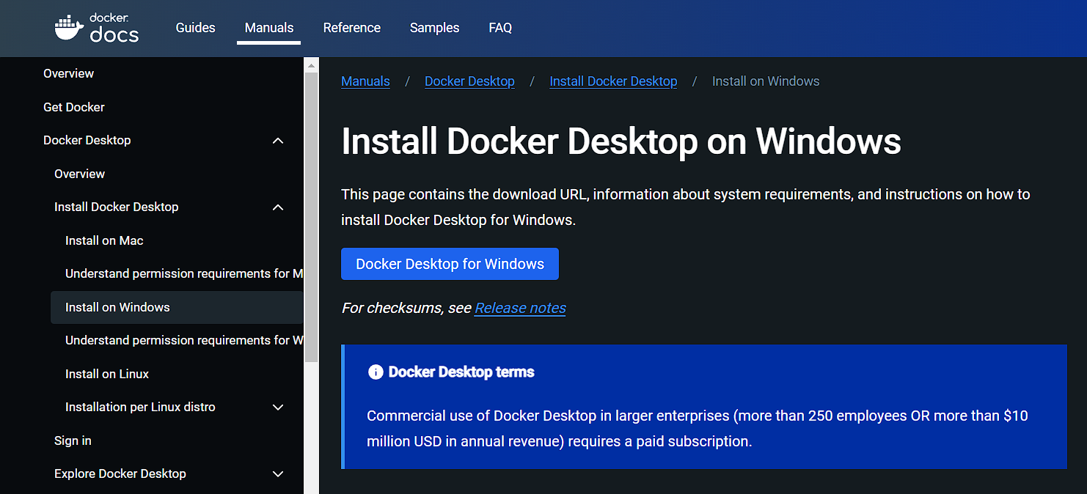

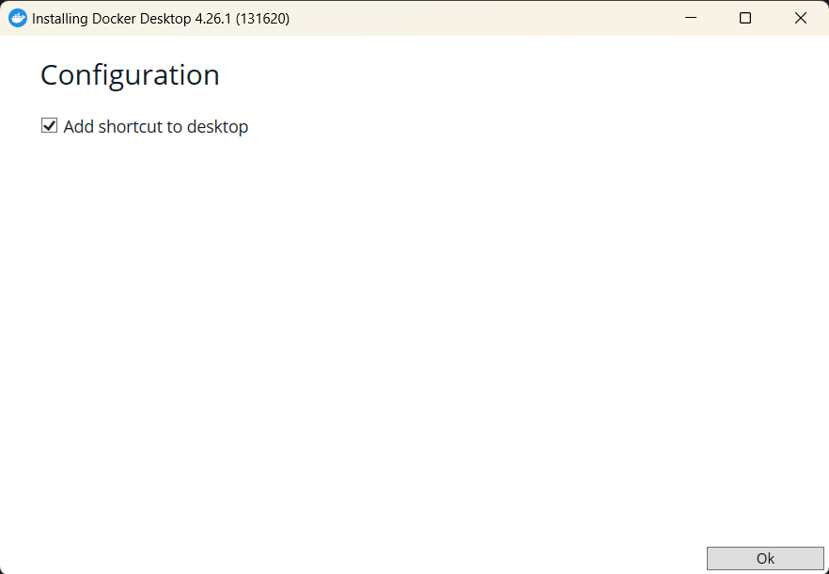

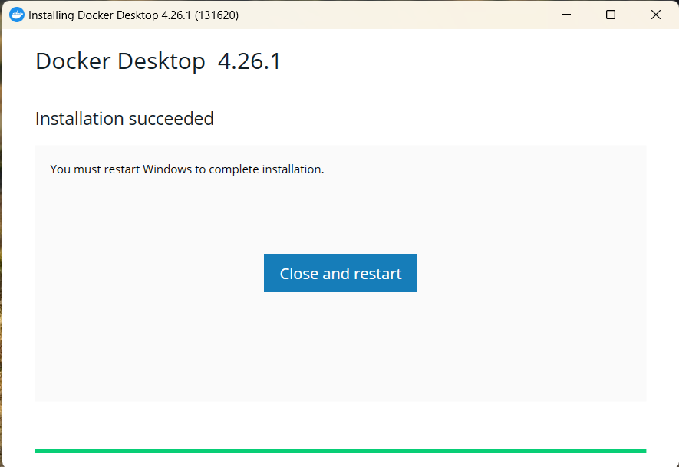

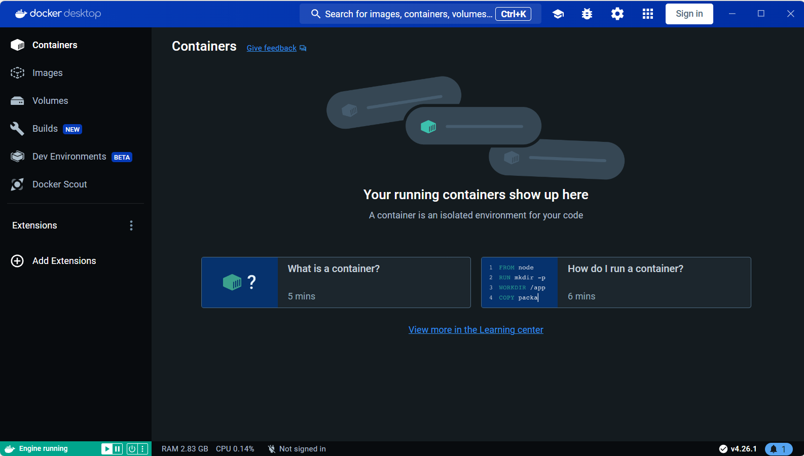

1. **Verify your Docker by looking up the version**

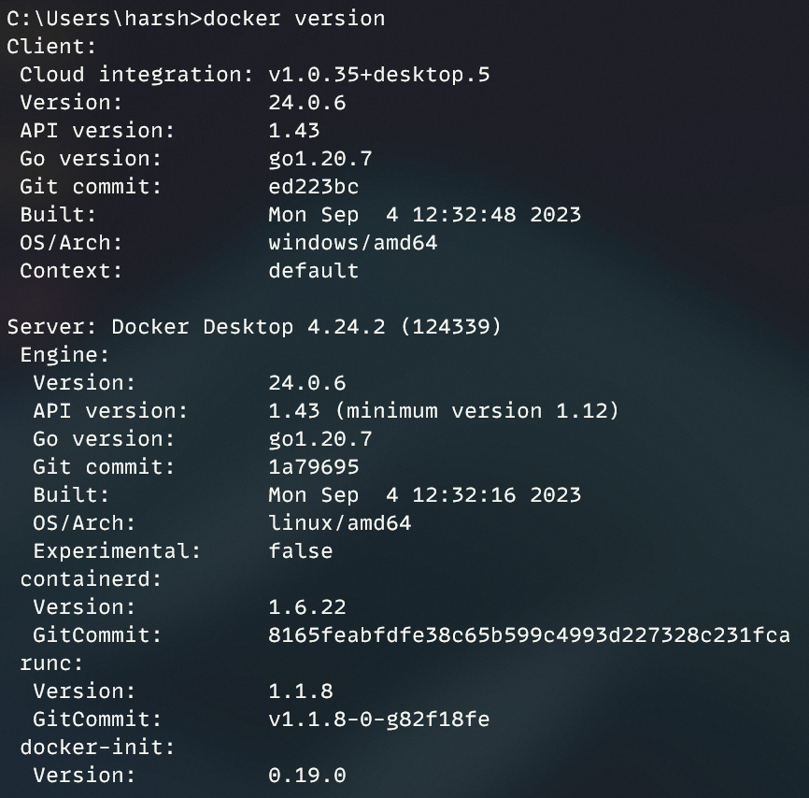

1. **Run a hello-world container**

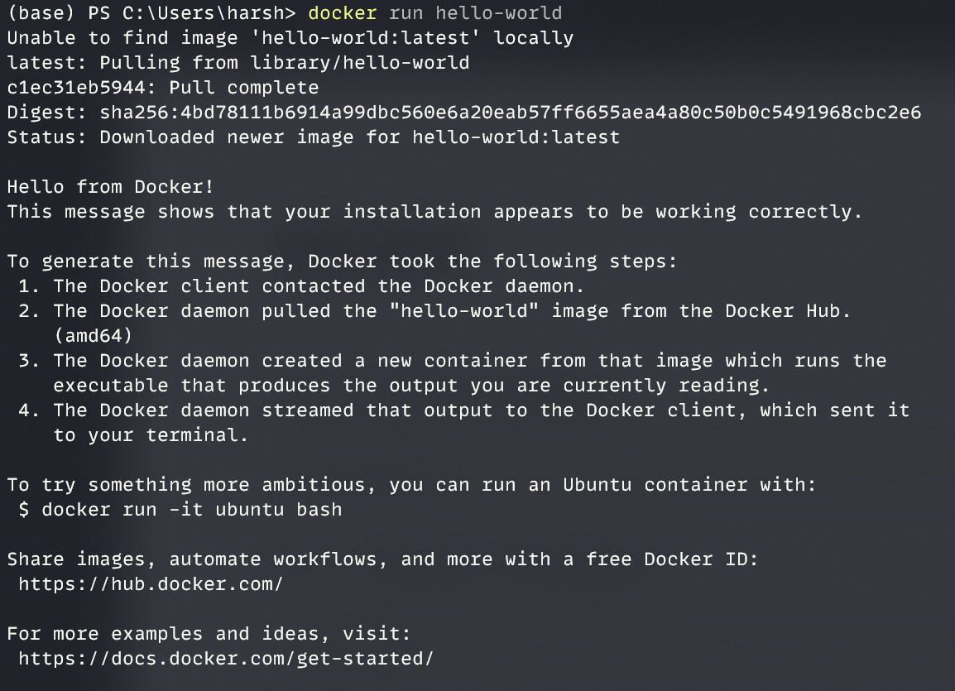

1. **Verify the hello-world image**

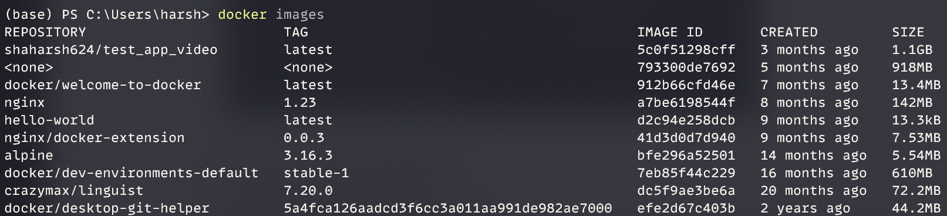

1. **Get the sample application**

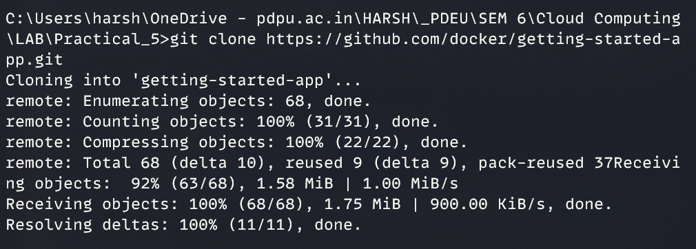

1. **Run the application on the Docker**
   1. **Build the Docker Image**

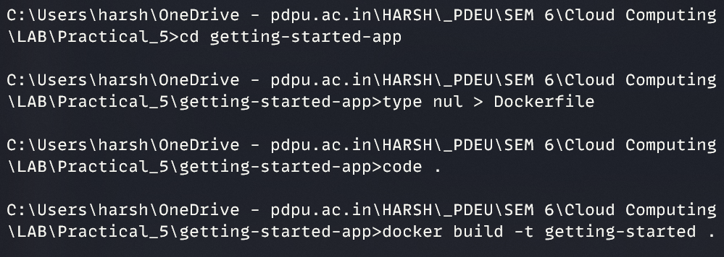

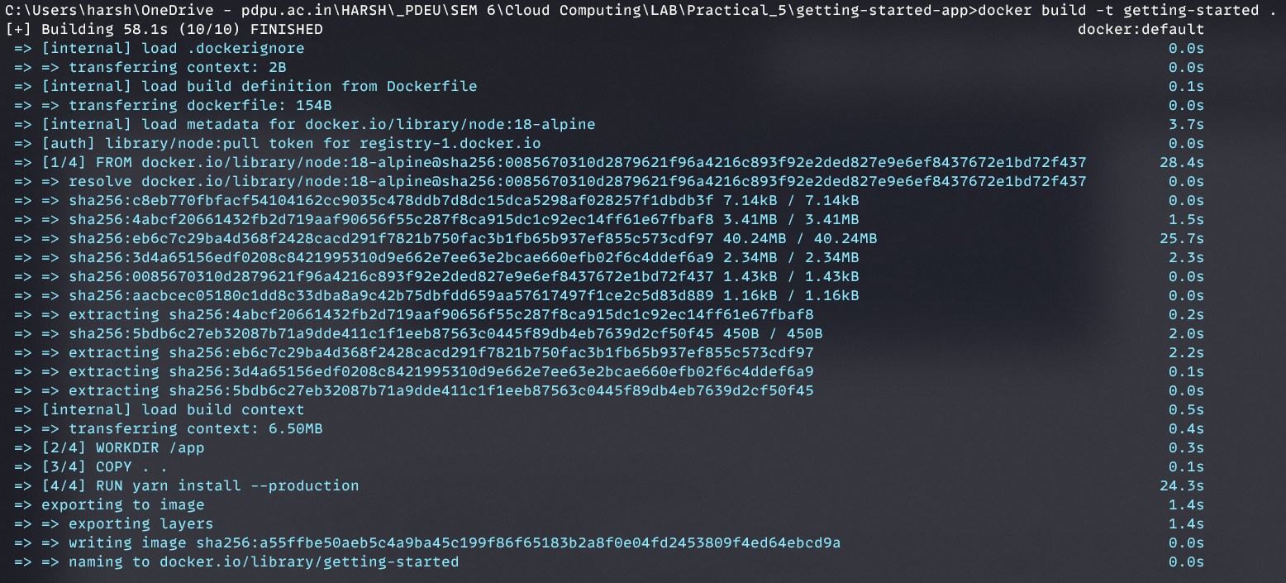

* 1. **Verify the newly build image**



1. **Run the Docker container**
   1. **Run the container in the detached mode. Name the container “Test Sample”.**

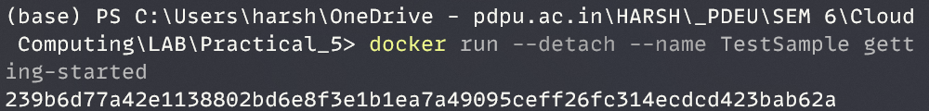

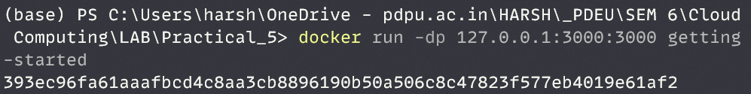

* 1. **List all the running containers.**



* 1. **Inspect the running containers**

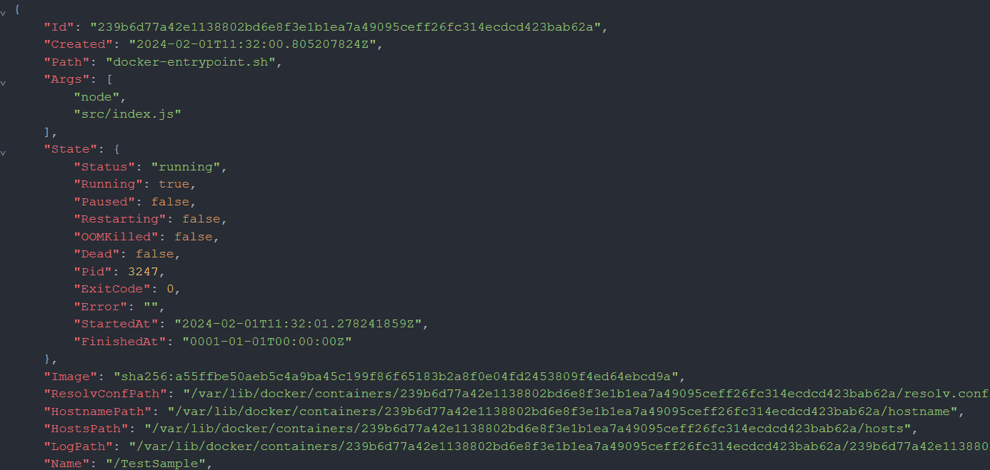

* 1. Get the logs of “Test Sample” containers

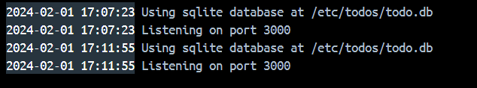

1. **Access the application**

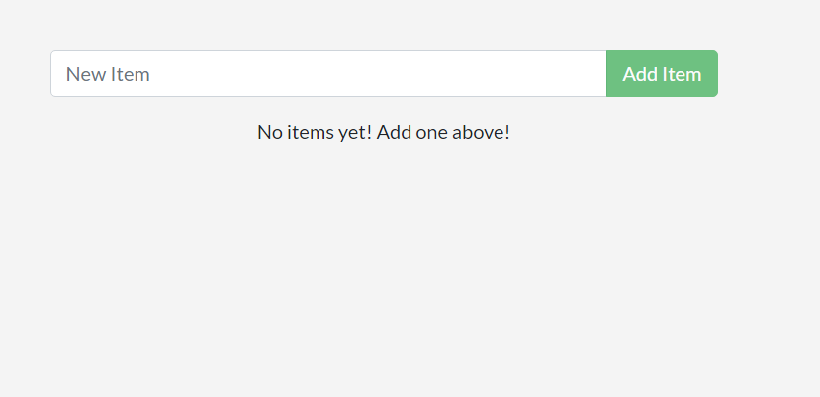

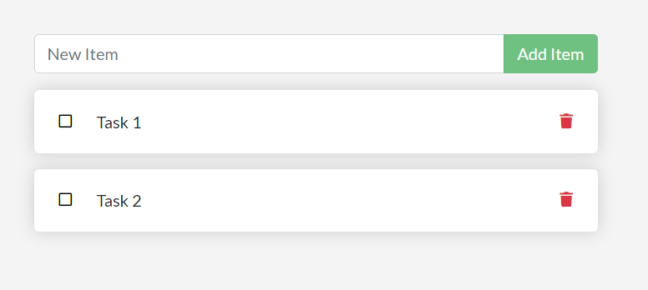

1. **Pushing and pulling an image to and from repository**

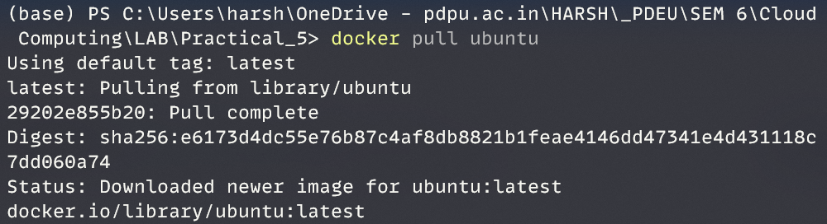



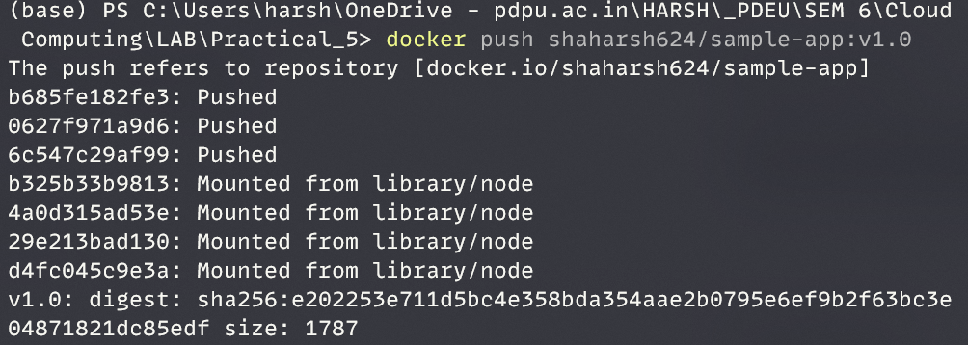

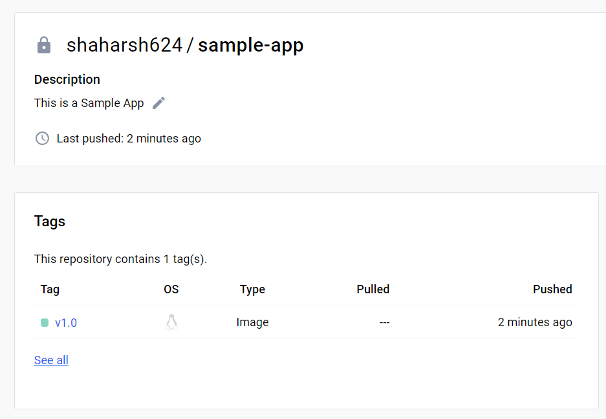

1. **Clean Up**

